**Q. Write a Problem Analysis Chart (PAC), Algorithm and Flowchart for checking whether a person is eligible for voting or not.**

PAC

|  |  |  |  |
| --- | --- | --- | --- |
| **Data** | **Processing** | **Output** | **Solution Alternatives** |
| Age | Check if ‘Age’ is greater than or equal to 18 | Print Eligible or Not Eligible |  |

Algorithm

* Start
* Use variable **Age**
* Read **Age**
* if **Age** is below 18

Print “Not Eligible”

else

Print “Eligible”

* Stop

Flowchart

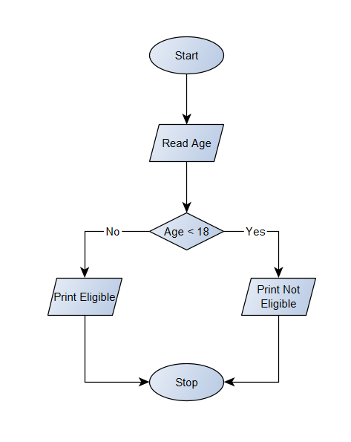

Python Program

Age = int(input(**"Please enter your Age : "**))  
if Age >= 18:  
 print(**"You are eligible for voting"**)  
else:  
 print(**"You are not eligible for voting"**)